**Experiment 1:**

**Circuit Diagram:**

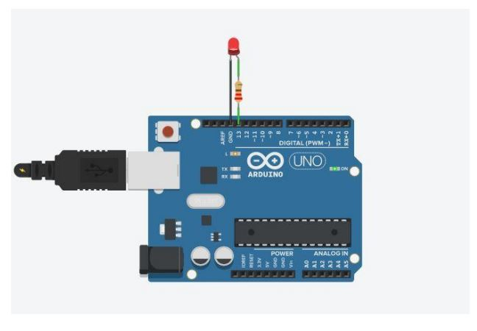

**Theory:**

**Concept used:**

Various concepts are used in this experiment as listed:

1. The LED.
2. Connection of Arduino Uno circuit board.
3. The code used to program the micro-controller.

**The LED:**

LED stands for “Light Emitting Diode”. An LED is a small light that emits visible light when an electric current passes through it. The light is not particularly bright, but in most LEDs it is monochromatic, occurring at a single wavelength. It is consists of two elements:

1. P-type Semiconductors
2. N-type Semiconductors

The positive side of LED is called “Anode” and the negative side of the LED is called “Cathode.” The flow of current is from anode to cathode but current cannot flow from cathode to anode that means it only allows forward current to flow through the circuit and block the backward current.

**Connection of Arduino Uno circuit board:**

In Arduino we have 14 input output digital pins numbered from 0 to 13 and on digital side we have one ground pin also. We can use any digital input output pin for input and output. In our experiment we use digital pin 13 through which we connect positive terminal of LED and the negative terminal of LED is connected to the ground pin named as “gnd” on Arduino board. Arduino is programmed to give output from digital pin 13 and ground provide return path way for current.

**The Code used to program the micro-controller:**

The code is the instruction which we give to the Arduino. In this experiment our code results in lighting up the LED for 1 sec and then dimming down the LED for 1 sec. As long as the supply is connected to Arduino, the LED continues to flashing.

**Learning and Observations:**

In this experiment we learnt about:

1. We learnt about the LED.
2. Basic coding used in Arduino Uno.
3. Interfacing an LED with Arduino Uno board.

**Observations:**

1. If we change the delay to any other value, the blinking of LED is also change according to the value of delay. For example we change the value of delay 1000ms to 2000ms, the blinking of LED become slower.
2. When delay become 50ms, then we cannot notice the blinking of LED. It look like it is continuously glowing.

**Precautions:**

1. The circuit elements should be properly connected.
2. The LED should be connected in proper orientation i.e. negative terminal of LED should be connected to the ground pin.

**Learning Outcomes:**

From this experiment we learn and acquire skills about:

1. Writing basic algorithm we used for flashing.
2. Working of Arduino along with the LED.
3. Application of digital pins of Arduino Uno Board.